**R ASSIGNMENT 3**

#Q1

print(pbinom(9,12,1/6)-pbinom(6,12,1/6))



#Q2

print(pnorm(84, mean=72, sd=15.2, lower.tail=FALSE))



#Q3

print(dpois(0,5,log=FALSE))

print(dpois(48,50,log=FALSE)+dpois(49,50,log=FALSE)+dpois(50,50,log=FALSE))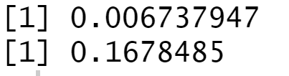

#Q4

print(dhyper(3, m = 17, n = 233, k = 5))



#Q5

print(dbinom(17, size = 31, prob = 0.447))

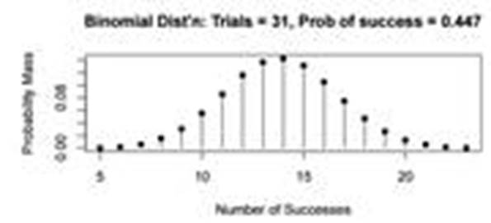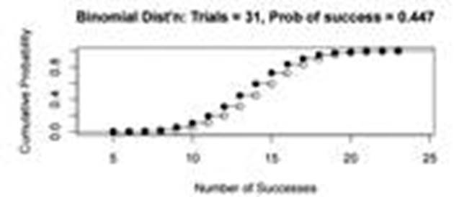

library(distrEx)

X=Binom(size = 31, prob = 0.447)

print(E(X))

print(var(X))

print(sd(X))

